Storm chasing field manual
  - Paired Sonde, ISCO and Level logger initial sampling setup
Contents
Materials checklist 2
Instruments 2
General 3
Procedure 4
Before leaving 4
In the field 4
ISCO 4
Sondes 10
Pressure transducer 11
Grab sample 11

Materials checklist at the start of the storm campaign

Instruments
Sampling:  - 110 acid washed ISCO bottles and bottle lids  - 8 1L acid washed bottles  - Coolers with ice packs (1 cooler per truck)  ISCO:  - ISCO  - ISCO battery  - ISCO tubing  - ISCO battery leash  - Plastic Battery box  - Spare ISCO battery (1x truck)  - Spare ISCO  - Spare ISCO tubing (internal and external tubes)  - Hose clamps  - Flat head screwdriver or socket driver for hose clamps  - Long tape measure  - Zip ties  - Diameter tape measure  - Voltmeter  - 1000 ml graduated plastic cylinder  - ISCO calibration bottle  - Soap  Pressure transducer:  - Level logger (Solinst)  - Laptop - PINEHEAD  - Cable for readout and launching of level logger (when bottles are retrieved)  - Cable for readout and launching of baro logger (when bottles are retrieved)  - Barologger + barologger housing  - Measuring stick  Sondes:  - Sonde handheld  - Sonde field cable  - Sonde(s) with calibrated sensors  - D batteries (x4 for each sonde + extras)  - Sonde case  - Sonde battery wrench | Rainfall gauge  - Calibrated rainfall gauge  - Wooden board  - Wood screws  - Hammer  - Screws  - Wood drill bits  - Spirit level  - Coin cell battery -CR2032  - Small screwdriver for battery replacement  - Cable for readout (when bottles are retrieved)  Miscellaneous:  - Keys  - Nitrile gloves  - Extendo Sampler  - Waders and/or boots-rubber boots  - Knife  - Duct tape  - Tablet with georeferenced maps  - Paper maps  - Permits, permissions, contact info  - Colorful ribbon for marking  - Field notebooks  - Field forms  - Extra Write-in-Rain paper  - Labeling tape  - Sharpies and pencils  - Tool box  - Pulaski, shovel, saw (for clearing debris off road. Required during fire season).  - Water pump backpack (summer field work)  - 5 gallon jug filled with potable water (summer field work)  Safety:  - Safety glasses  - Work gloves  - Spot unit  - Ear protection  - Hard hat  - First aid kit

General
Tools:
- Crimpers

- cable cutters (small)
- Bolt cutters (big cable cutter)
- Plastic mallet (plastic hammer)
- Sawzall (reciprocation Saw )

- Socket wrench (find large drive wrench)
- Hose clamp socket
- Epoxy gun
- Rock Drill
- Rock Drill bits

Hardware:

- 1/4" coated cable
- 3/16” coated cable

- Small and large cable u-bolts
- 3/16” ferrules
- Hose clamps
- Carabiners (1x sonde)
- ½” wedge anchors

Procedure

Before leaving

At least one week before leaving:
- Make sure that the ISCO are working, and the desiccant is blue (check field preparation sop).
- Ensure you have enough acid washed ISCO bottles, 250 ml and 1 L bottles for lab analysis (check Lab sop).
Two or three days before leaving:
- Reserve the trucks at OSU motorpool needed for sampling.
- Upload maps to tablets and confirm Avenza is working
- Check the weather for windy conditions and fire danger (NOAA is a good source for wind and snow levels)
- Print field forms on write-in-rain paper.
- Double-check that you have everything on the material checklist above and don’t forget the lock keys!
- Launch sondes (lab preparation SOP)
- Launch barologger (lab preparation SOP)

- Launch rainfall gauge (lab preparation SOP)

In the field
Check out text: Send a group text in Teams to the let group know your general plan and your estimated time of return
Good practice: say out loud all the steps you are taking in the field.
- Take a general look around the site– are there any new failures on the slopes or banks? Are there any new trees or rootwads that have fallen over?
- Fill out the general information on the “field_form_stormchasing.pdf” (file location: “T:\Research\Wildfire_Water_Security\02_Nodes\01_Empirical\05_Projects\storm chasing\Lane1\forms”)

  - Record the site name (as shown on the map)

  - Record the date in the yyyy-mm-dd format

  - Record the time as 00:00 format, in Pacific Standard Time

  - Record the field crew members’ (OBS = observer) initials

  - Record the weather (WX) – Is it raining? Is it clear and sunny? Is it windy?

Grab sample
      - Label the sample: XXXXXXX.

      - Record in the field notes the name of the sample, the bottle number and the day and hour you collected the sample.

      - Rinse the bottle of the extendo sampler 3 times with the creek water

      - Rinse the 1L sample bottle 3 times with the creek water from the extendo sampler

      - Fill the 1L sample bottle with creek water leaving no headspace.

      - Place the bottle in the cooler

      - Back to the lab, place the bottles in the fridge room in Richardson.

      - The next day or within 48 hours filter the samples as described in the lab sop.

ISCO

Battery safety notes
- While handling:
- Do not drop or damage the batteries – they have the potential to leak battery acid. If battery acid does spill, wear gloves to clean with soap and water.
- Do not allow the terminals to be shorted (i.e., do not allow metal or something conductive to contact both terminals at the same time)
- During transport:
- Keep the batteries secured in the back of the truck. DO NOT store anything on top of batteries during transport – this could lead to a short circuit connection between both terminals, causing the batteries to start smoking.
- Leave terminal caps in place until the battery is ready to be hooked up to the ISCO.

Instrument installation
- Find a flat area to locate the ISCO, outside the flooding area of the stream. Locate it close to a trunk.

- Secure the ISCO with the cable to a trunk. Be sure the ISCO is stable and does not move.

- Clip the positive (red) first, then the negative (black) terminal of the battery leash to the battery.

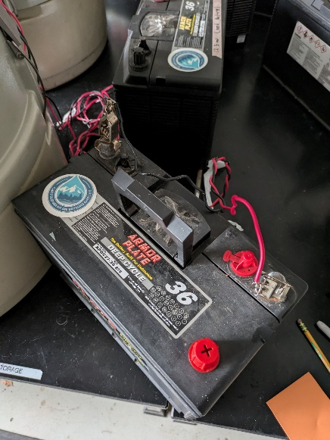

- Carefully screw and plug the ISCO to the battery leash, on the back of the display, to connect it to the battery.

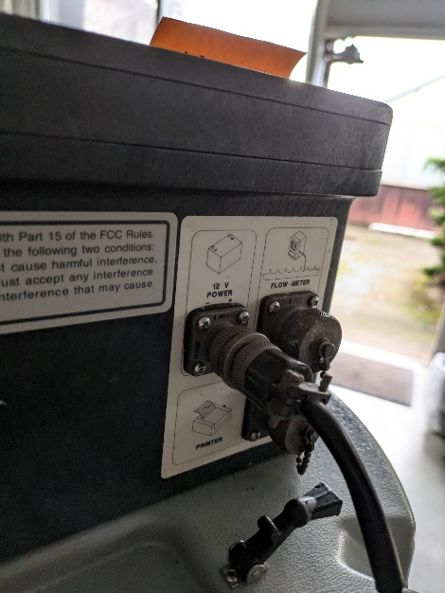

- Close the lid of the battery box. Be sure it is well closed.

- Place the ISCO tube in the water, position it close to the PVC or sonde pipe and tie it with the zip ties. Make sure the pipe does not interfere with any sensor and vice versa.

- Connect the ISCO tube with the coupler.

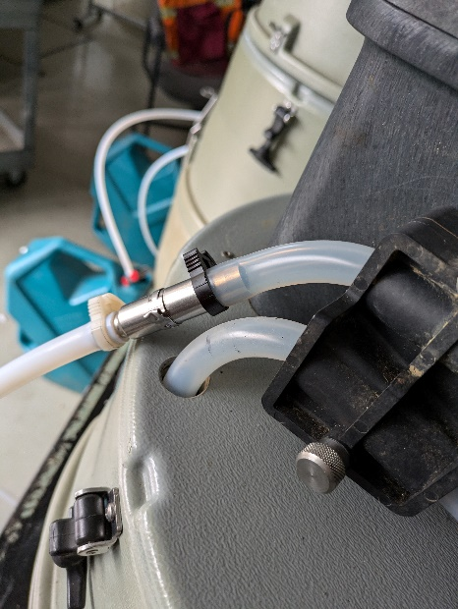

Checking the Configuration Option Settings

- Turn the ISCO on or deactivate standby mode by pressing ENTER/PROGRAM.

- After pressing ENTER/PROGRAM, select the “CONFIGURE” option by pressing the RIGHT ARROW key once. When “CONFIGURE” blinks, accept the selection by pressing the ENTER/PROGRAM key.

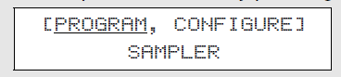

- The first option is to set the clock. Press the ENTER/PROGRAM key to access the set clock input display. Use this display to reset the time. Five entries are required. The LEFT ARROW and RIGHT ARROW keys can be used to move back and forth between each of the five entries. Use the arrow keys until the entry you want to change blinks. Type in the new time or date (watershed time); press the ENTER/PROGRAM key to accept it. Press the RIGHT ARROW or ENTER/PROGRAM key on the last entry to store the values and advance to the next display

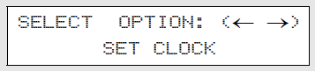
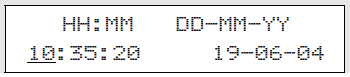

- Under the BOTTLES AND SIZES menu, verify that the settings reflect the bottles being placed into the sampler. Press ENTER/PROGRAM to proceed after this step is completed. For our protocol, the bottles are plastic and 1000mL.

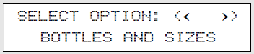

- Under the next menu select the “PORTABLE” option and press ENTER/PROGRAM.

- Under the next menu select the number of bottles in the base (for our purposes this will always be 24). Press ENTER/PROGRAM to proceed after this step is completed.
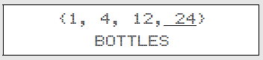

- Under the next option, input the bottle volume (for our purposes this should always be 1000 ml). Press ENTER/PROGRAM to proceed.
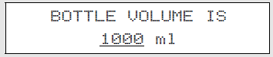

- Press ENTER/PROGRAM to display the “SUCTION LINE” options.
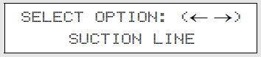

- Press ENTER/PROGRAM to select the correct suction line diameter (this will be 3/8 inch).
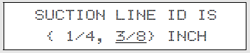

- For suction line material select the “TEFLON” option and press ENTER/PROGRAM.
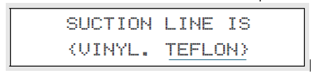

- Under line length, input the correct length of the tubing in feet. This should be recorded when the sampler is installed. Press ENTER/PROGRAM to proceed.
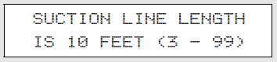

- Press ENTER/PROGRAM to access the liquid detector input.
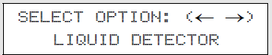
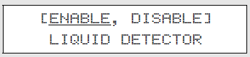

- On the second screen select the desired number of rinse cycles—we have been using 2. Press ENTER/PROGRAM key to accept the entry.

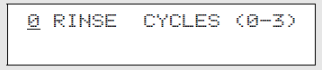

- This display appears when you select “ENABLE” in step 12. Select “NO”. Press the ENTER/PROGRAM key to accept the selection.
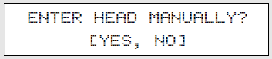

- This display appears when you select “ENABLE” in step 15. Set the number of retries to “2.” Press the ENTER/PROGRAM key to accept the entry. This setting determines the number of times the sampler will try to detect the presence of liquid for each sample event.
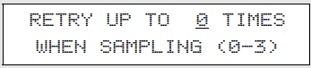

Programming Sequence (Will be performed each time)

- Check that the ISCO has 24 ISCO bottles inserted.

- If needed, after wearing nitrile gloves take off the lids of the bottles and store in a zip bag placed in the center of the ISCO.

- Turn the ISCO on or deactivate standby mode by pressing ENTER/PROGRAM.
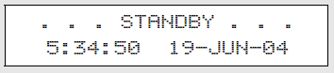

- Access the program sequence by selecting “PROGRAM.” Because “PROGRAM” will already be selected (blinking), press the ENTER/PROGRAM key to accept it and move to the next step.


- Press ENTER/PROGRAM to select the TIME option for paced sampling.
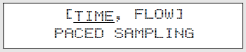

- Under “SAMPLE EVERY” input the desired sampling interval in hours and minutes. This display requires two entries: one for the hours, one for the minutes. Enter “0” to set the hours at zero. Press ENTER/PROGRAM to accept the number “0” and move to the minutes entry shown in step 5. Set it at X HOURS, Y MINUTES

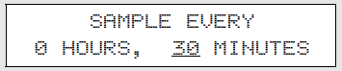

- Select NO for multiplexing samples, press ENTER/PROGRAM.
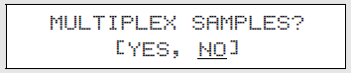

- Input the desired sample volume and press ENETER/PROGRAM. For our protocol we will be sampling 900 ml.
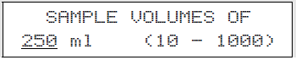

- CALIBRATE ISCO: Calibrate sampler, select YES
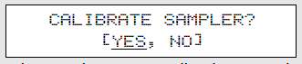

8.1. Press the MANUAL SAMPLE key

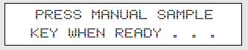

8.2. Measure the actual volume delivered using the graduated cylinder and enter the value
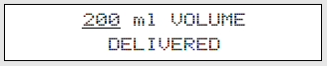

8.3. Repeat the procedure if desired by selecting “YES.” When you are satisfied with the calibration, select “NO.”
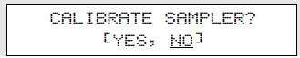

- In the next menu, select YES and input the desired start time. If the sampling needs to start immediately, select NO.

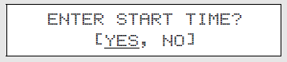

- Repeat aloud all the steps taken from here to the end: Enter the time and date you wish the first samples to be collected. Note: Time is in 24 hour clock.
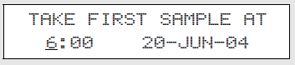

- After you the previous step, you should receive the message “PROGRAMMING SEQUENCE COMPLETE”, which will then return you to the standby mode.
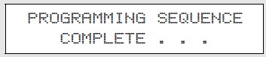
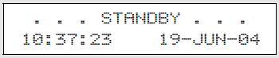

- CRITICAL STEP: To run the program, press the START SAMPLING key, which will then ask you which bottle to begin sampling. Input BOTTLE 1 and the run sequence will start.
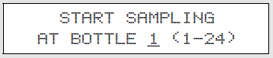

- The display should then look something like this. The first line of this display indicates the start time. The second line reports the current time and date.
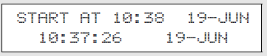

- Take a picture of the display with the tablet.

Sondes

Check list:  - Sonde handheld  - Sonde field cable  - Sonde(s) with calibrated sensors  - D batteries (x4 for each sonde + extras)  - Sonde case  - Sonde battery wrench | Hardware:  - 1/4" coated cable  - 3/16” coated cable  - Small and large cable u-bolts  - 3/16” ferrules  - Hose clamps  - Carabiners (1x sonde)

- Cut a length of cable which will be used to pull the sonde out of the pipe. Create a loop at one end of the cable and secure using u-bolts (x2). Using a carabiner, secure the sonde bail (the black loop on the top) to loop in the cable.

- Then secure the opposite end of the cable to the cable hole at the top of the housing using u-bolts.

- Launch/program the sonde using the YSI handheld controller for 15-minute intervals (for more instructions on programming the sonde, see further documentation on Sonde-program-SOP.docx)

- Make sure the red light on the sonde is pulsing once every 10 seconds, that means the sonde is launched and ready to work!

- Once the wire rope is secured to the sonde bail with a carabiner, slide the sonde down the pipe so that it reaches the bottom and is submerged.
  - Note: You may have to push the wire rope a bit, shimmy the sonde, or pull it back out and retry with more momentum if it gets stuck. If it’s really stuck you can use the extendo sampler to push it down the tube.

- Use the long-shackled padlock or bike lock to lock up the end of the tube for theft prevention.

Before you go, make sure the sonde is launched, locked, and loaded (with the proper programming)!

Pressure transducer

- Cut a length of cable which will be used to pull the transducer out of the pipe. Create a loop at one end of the cable and secure using u-bolts (x2). Using a carabiner, secure the sonde bail (the black loop on the top) to loop in the cable.

- Then secure the opposite end of the cable to the cable hole at the top of the housing using u-bolts.

- Put the Solinst pressure transducer in the PVC tube.

- Checking bottom to make sure levelogger is w/in its housing.

- Using a measuring stick, measure from base of stilling well to base of stream.

